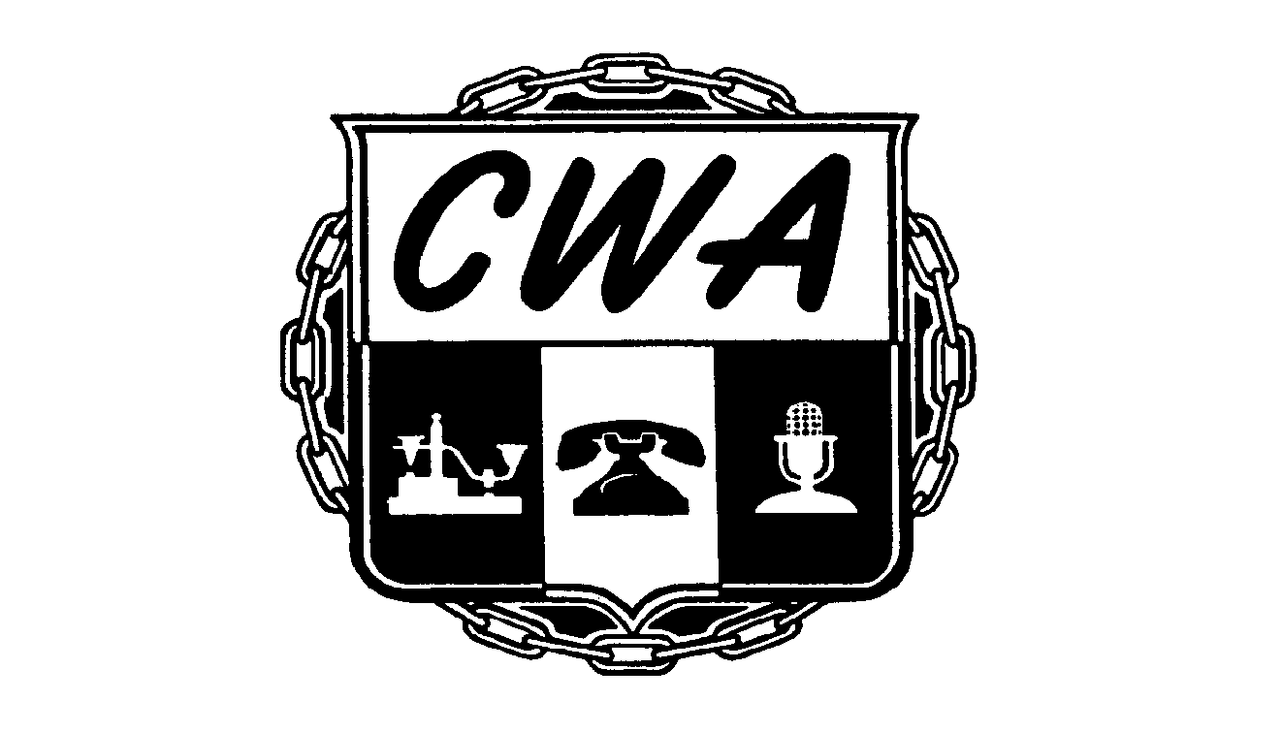
*Bargaining Arrangement
60/40 ☑ OR 70/30 

Contract Bargaining - Prep Notice
(Please provide/confirm the following information)

Date: December 4, 2024

To: Decovan Rhem, President Local 9415

From: Domonique Thomas, Assistant to the Vice President

Re: Women's Foundation of CA

Duration: March 1, 2024 – February 28, 2025

Employees Covered by contract: __7___

Employer Rep Name:Kanitra Lopez

Employer Title: Director of People and Experience

Employer Address:
1301 Clay St. #71719
Oakland, CA 94612
Employer Tel#:916-538-3193
Fax: _____________

E-mail: kanitral@womensfoundca.org

Location(s) of Affected Establishment: California

Local Bargaining Chair: Jason Montgomery

Email jmontgomery@cwa9415.org

*Bargaining Arrangement Policy:

60/40 Dues Split
This arrangement is agreed upon by the District and the Local and it covers costs and assistance in bargaining contracts, however District 9 Staff will not chair the bargaining table. District 9 Staff will be accessible to the Local’s appointed and/or elected bargaining committee.
70/30 Dues Split
Local Unions negotiate contracts and handle all grievances, arbitration cases, legal expenses and dues collection in those units that do not exceed 150 potential members. District 9 does not negotiate, handle grievances, arbitrations, legal costs or dues collections on 70/30 units. Withdrawing from 70/30 status requires action of the local executive board.

cc: Cherie Brokaw, Staff Representative
Lynn Johnson, Area Director

DT/am
OPEIU29 AFL-CIO (233)

Rev. 8/11/23

