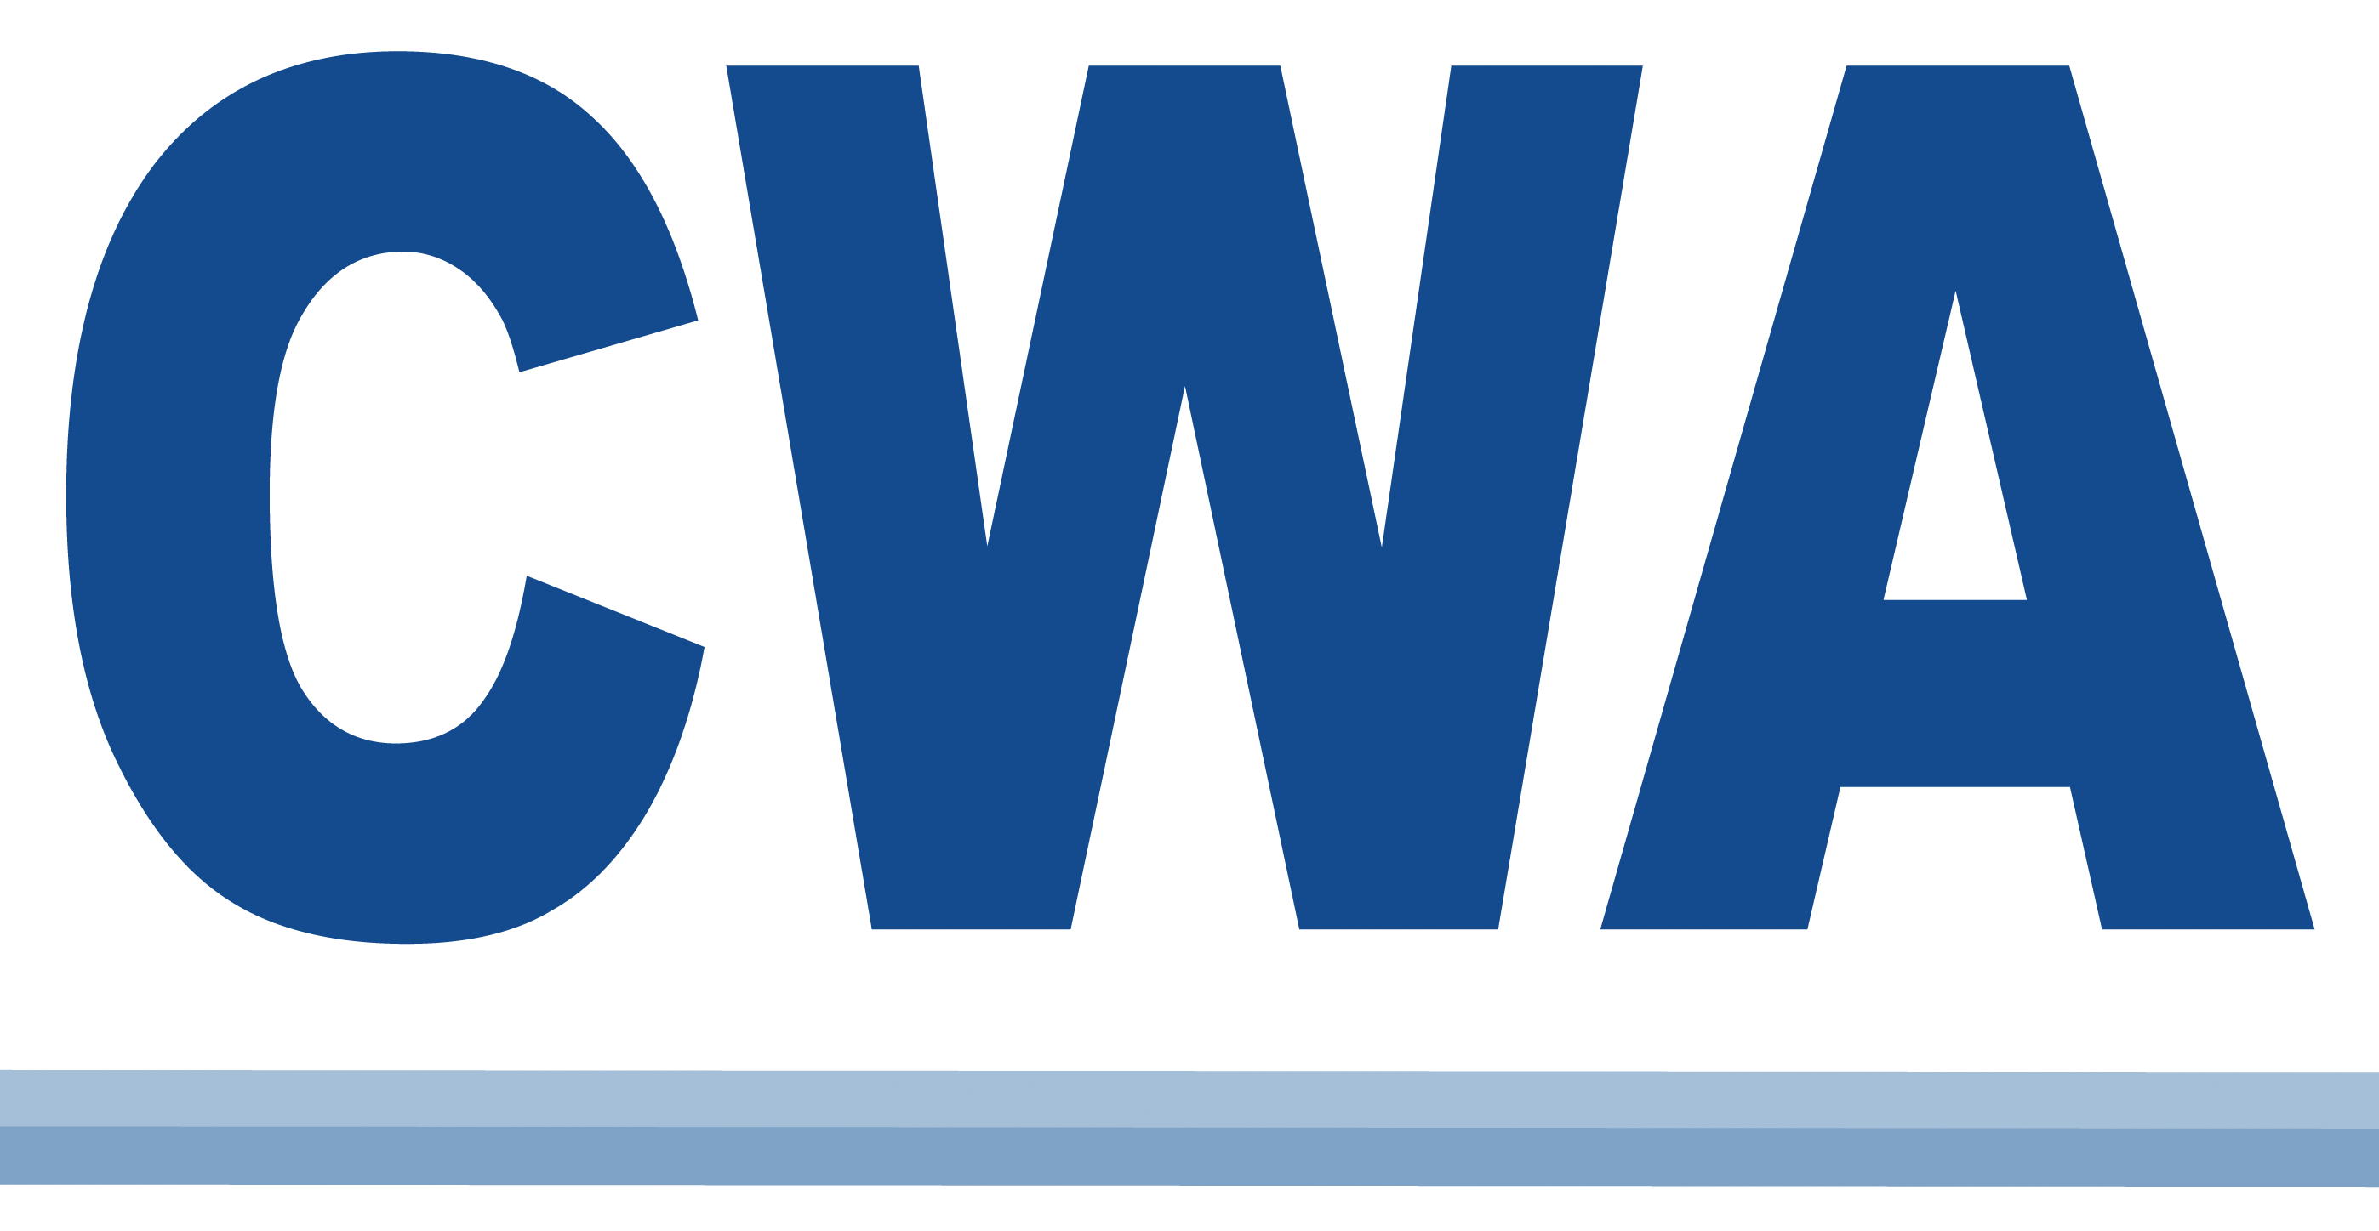 | PROJECT COMPLETION NOTICE
  Forward to:
  CWA Membership & Finance
  501 Third Street, NW
  Washington, DC 20001-2797
  DuesPU@cwa-union.org
 | TO BE COMPLETED AFTER
 | RECOGNITION OR CERTIFICATION

1. Date of Election (if applicable): N/A

2. A. Employer: Rainforest Action Network
B. Bargaining Unit (Describe Work Force): Non-Profit Staff Workers
- Subsidiary of (if applicable):

3. A. Employer’s HQ Location: (City and State) San Francisco, CA

B. Bargaining Unit Location: (City and State) Remote workers throughout the US.

4. Product and/or type of business: (Describe Fully) Rainforest Action Network preserves forests, protects the climate and upholds human rights by challenging corporate power and systemic injustice through frontline partnerships and strategic campaigns.

5. A. Staff assigned to negotiate the contract: Jason Montgomery
OR
- Unit to be folded into existing unit; if so, give existing unit number:

6. A. Potential members: 30
- Actual members: 27
- Local jurisdiction assigned: Existing Local # : 9415
OR
- New Local charter: Proposed Local # :

7. Employer (unit) number assigned:

- How was recognition obtained: Voluntarily

9. Election vote record: CWA No union Other union
Challenged Void Total

10. Unit organized by: (Name, Title, Local If Applicable) Joan Kaufman, District 9 and Local 9415 Organizer

11. DOP # :

12. This is a (check one of the following): 13. Form 9 prepared by:
Jason Montgomery
Telephone Service (including regulated and non-regulated)
Communications Systems Industry Company 14. A. Received by Contract Section:
Public Workers Unit (Right to Strike) __________________________
Public Workers Unit (No Right to Strike)
Service Worker Unit B. Processed by Contract Section:
General Manufacturing Company __________________________
Miscellaneous

FOR DUES DEPARTMENT USE ONLY
DISTRIBUTE TO:
Organizing
Compliance | And, if applicable to:
Membership Dues | Sector Vice Presidents
District VP
Labor Management Pension Fund

Form 9
Rev 04/16

